Thermo Shaker for Microplates—TS300
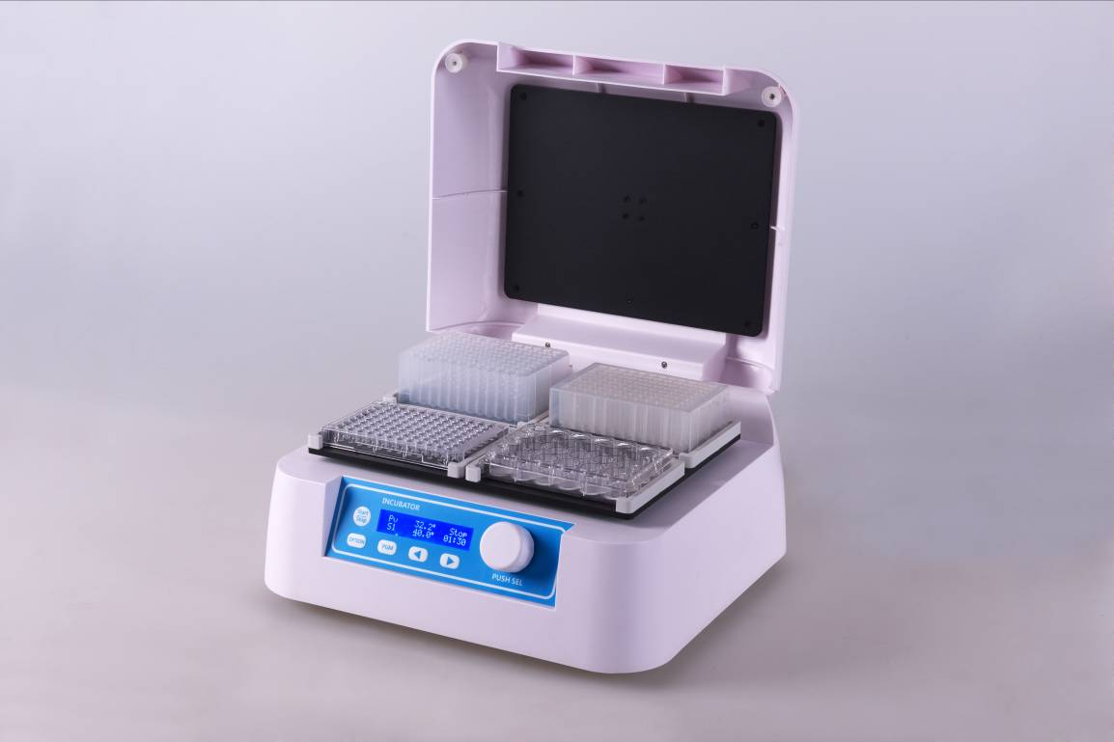

Introduction
TS300 thermo shaker for microplates is a multipurpose thermostatic shaker controlled by brushless DC motor and PID intelligent temperature control technology. which PID fuzzy control technology can accurate to ensure that the temperature control precision and automatically adjust the heating rate, reduce waiting time. TS300 combines constant temperature and oscillation perfectly together, greatly shorten the experimental operation time, which is the ideal automation tool for samples hatching, catalytic reaction process of preserving, blending, save and etc.
Features:
- Easy to set up and use, all information real-time display and showing setup operation, convenient to observe equipment running status.
- Support standard microplates and deep well plates.
- Brushless DC motor, low noise, small interference, free maintenance.
- Automatic preheating function.
- Automatic power recovery function.
- Temperature calibration function.
- Built-in software and hardware over temperature protection device, will use more reliable.
Applications:
- Storing samples at ice bucket temperatures.
- Storing enzymes or DNA libraries at your workstation.
- Transporting samples from the field at exactly the right temperature.
- Heating samples in the field.
- Enzyme reactions and deactivations.
- PCR sample preparation.

Parameters
Model | TS300
Temp setting range | 0℃~80℃
Temp control range | RT+5℃~80℃
Time range | 1min ~ 99h59min/∞
Temp accuracy | ≤±0.5℃*
Display accuracy | 0.1℃
Temp uniformity | ≤±0.5℃*
Speed range | 200~1350rpm
Orbit | 3mm
Heating time | ≤15min(from 25℃ to 80℃)*
Auto preheating | Yes
Auto resume to run | Yes
Capacity | 4 Microplates or Deepwell plates
Power supply | 300W
Voltage | AC220V or AC110V /50-60HZ
Fuse | 250V 3A Ф5×20
Dimension(mm) | 340x320x200
Weight | 9.5kg

